AWS-CHALLENGES
To create key in aws console
First go to aws console and click on kms ( key management service)
And then click on create key and select symmetric and usage encryption and decryption
Alieas s3 encryption key add alias example alias my app assigm key adminstrators and users
Click on create key
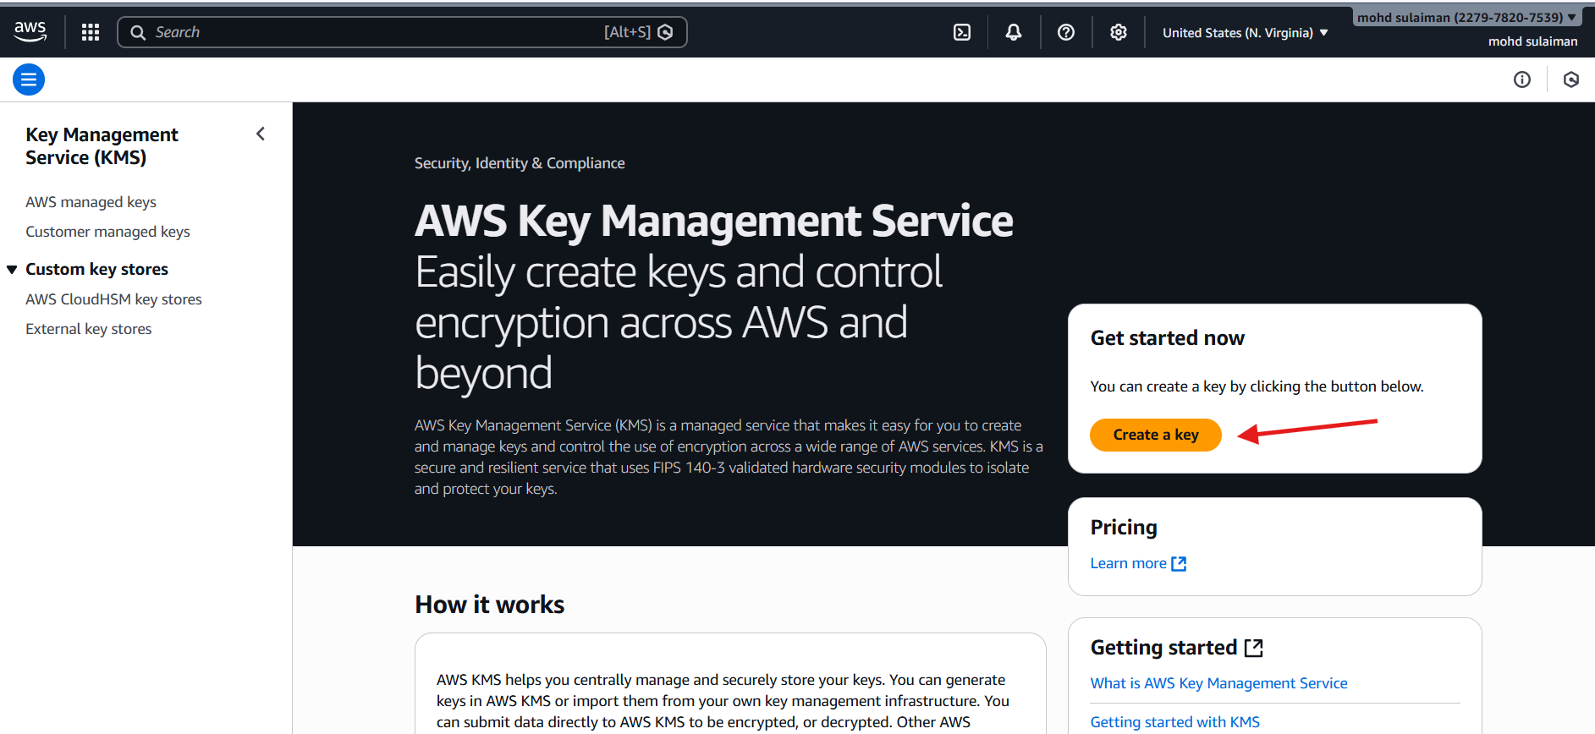
Click on next
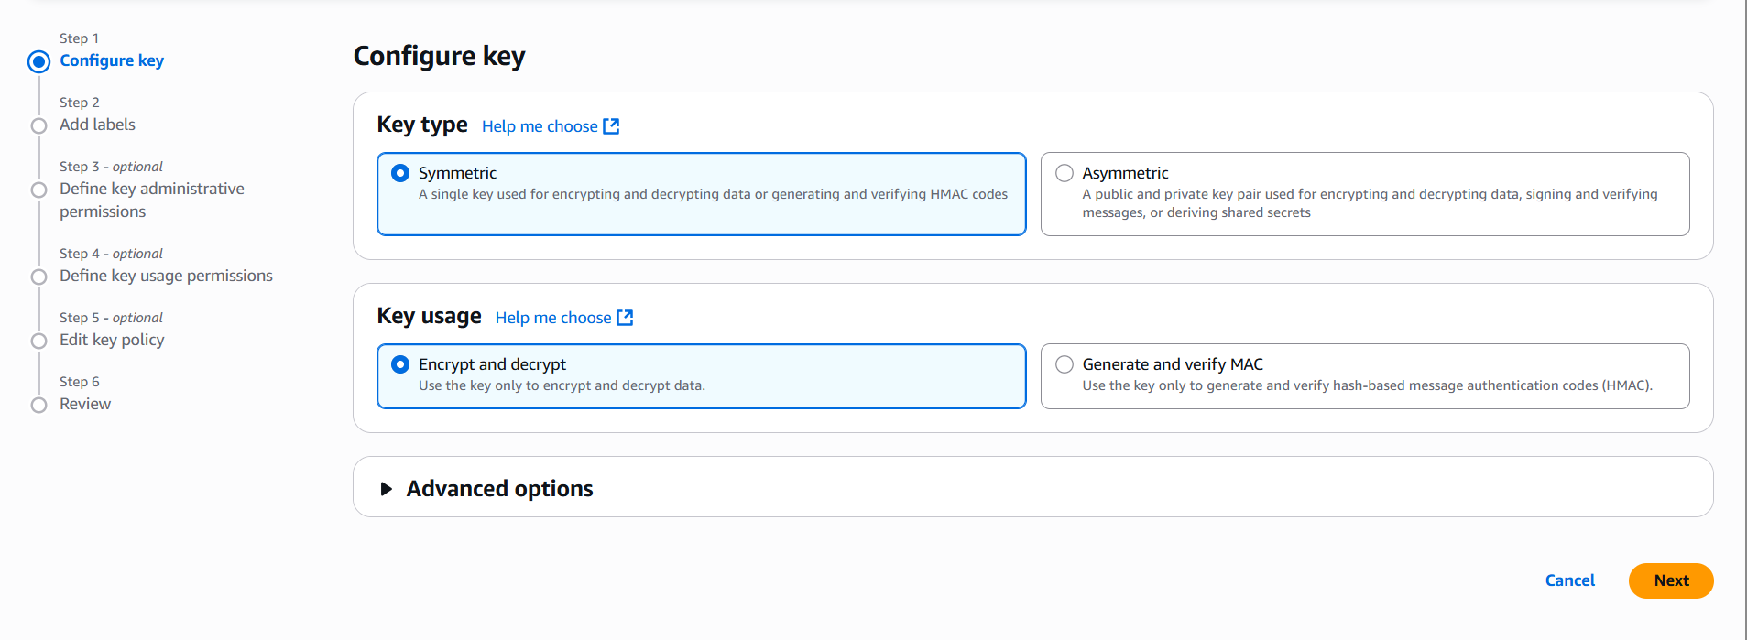
Now give your alias name in our case giving it my-app then click next
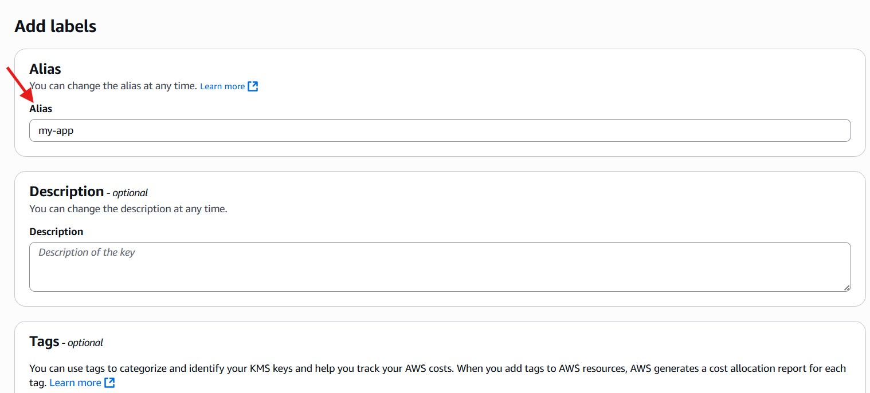
Now tick on admin-user
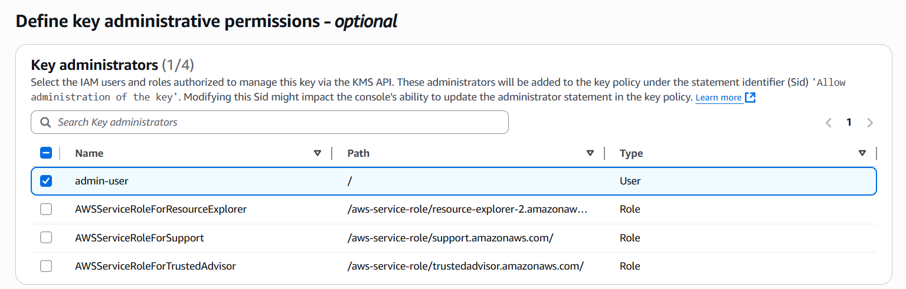
Now step 4 tick on admin
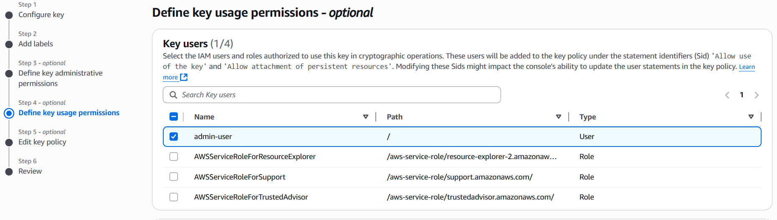
Now review your policy
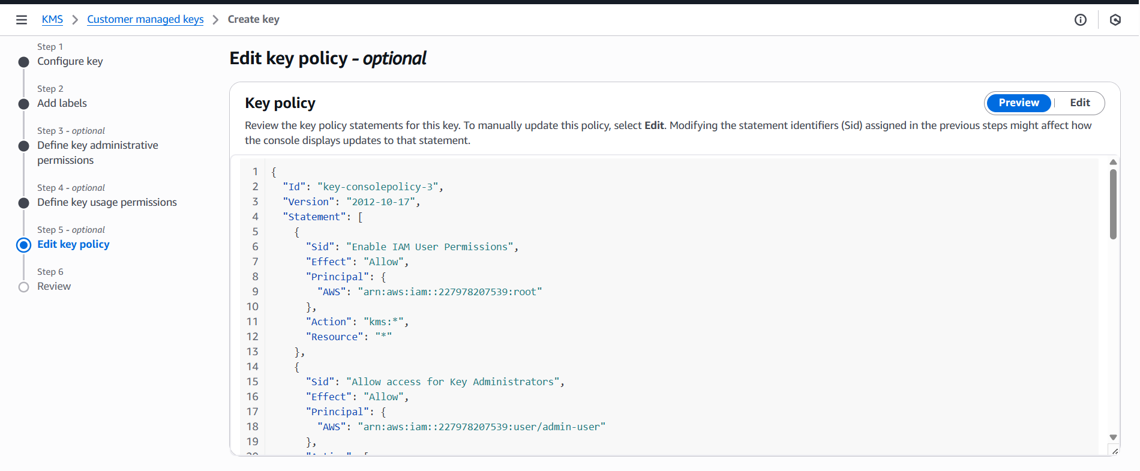
That’s now review all policy
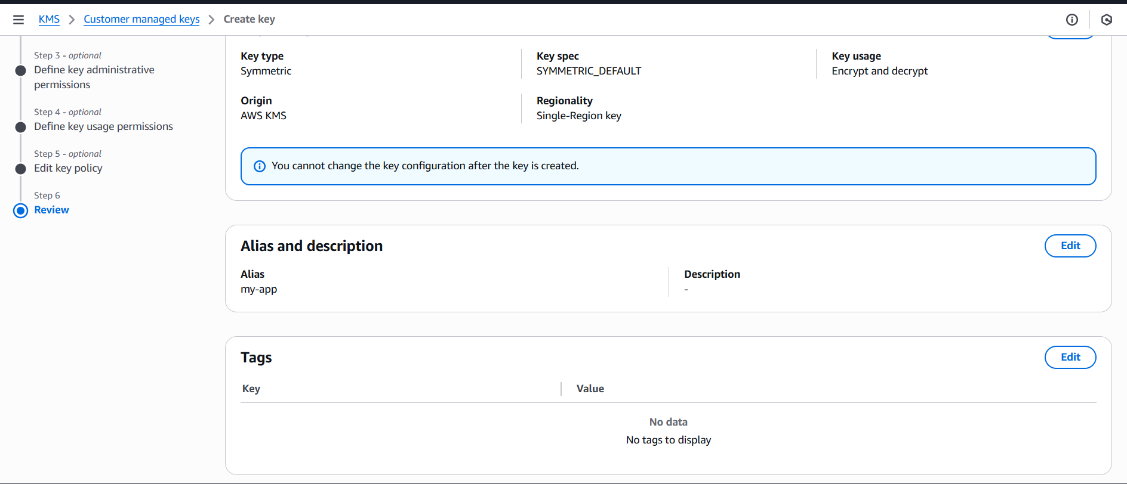
Its our policy
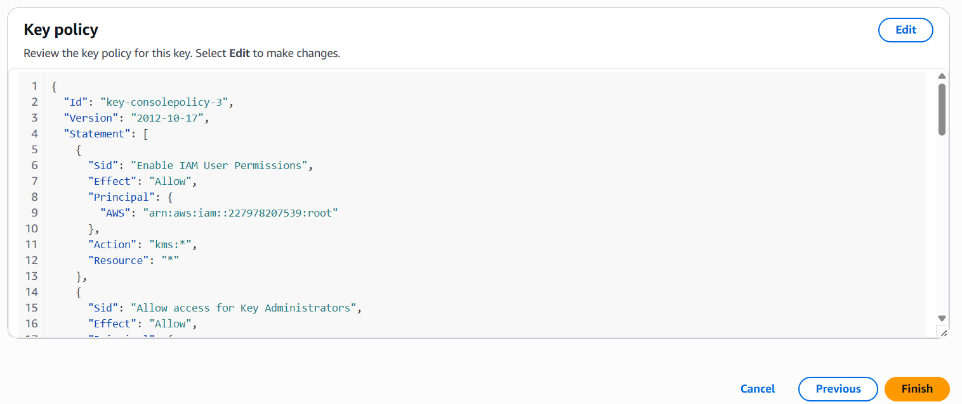
Now click on finish that’s successfully created our app
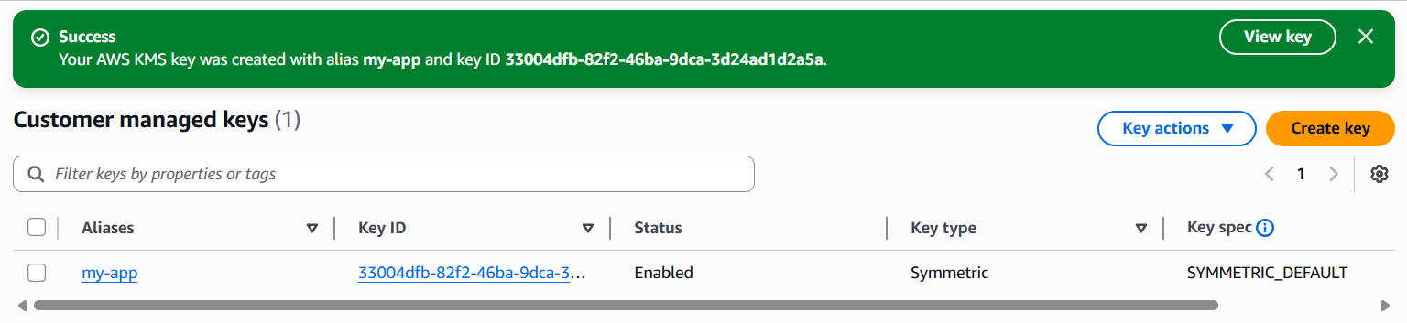
2. Using KMS Key in S3 Encryption
- Go to S3 → Bucket
- Open Properties
- Enable Default encryption
- Select AWS KMS
- Choose alias/s3-encryption-keyUpload a file
- Confirm encryption = aws:kms
- Create the s3 bucket
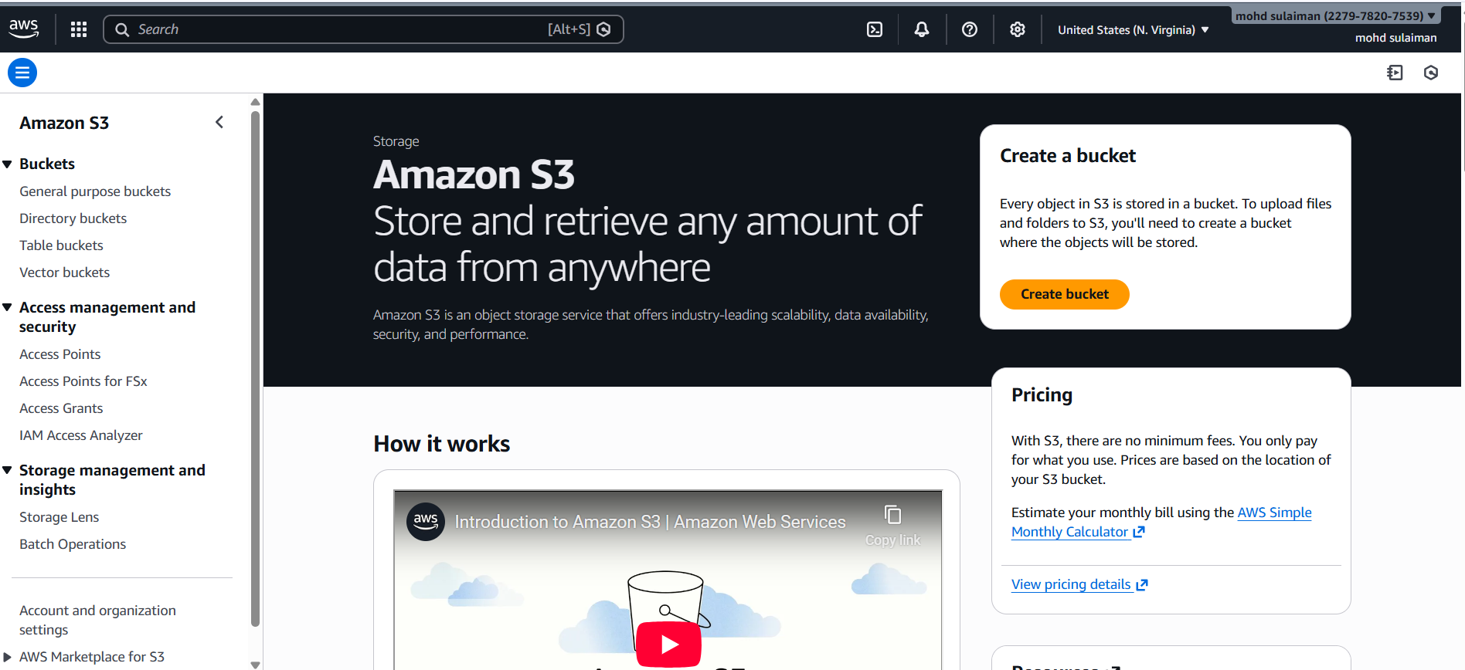

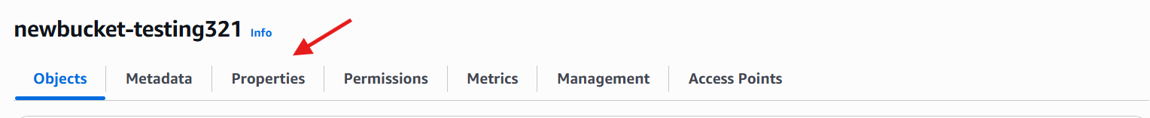

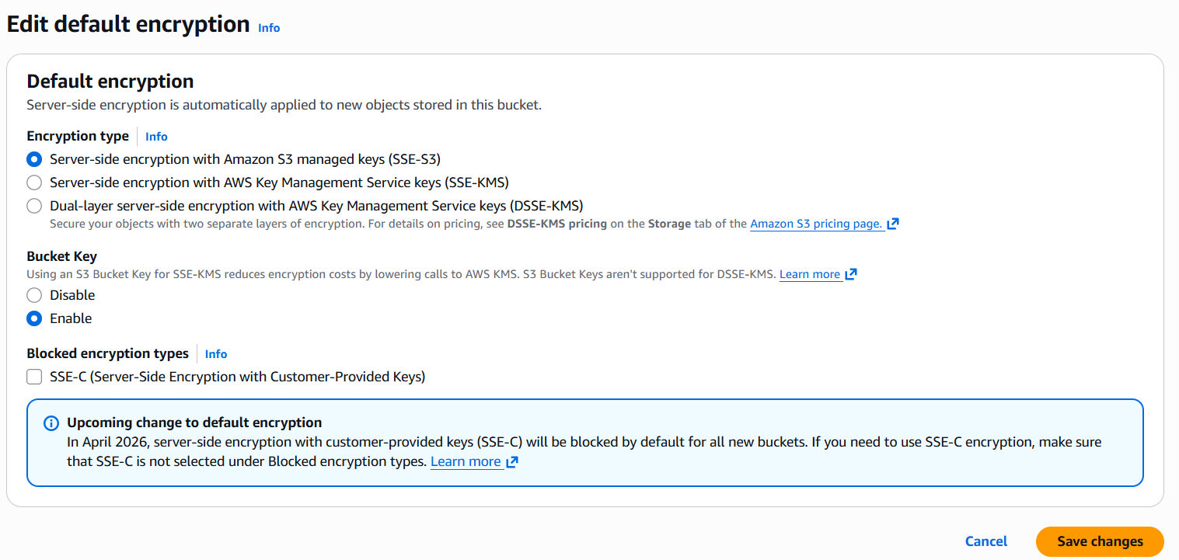
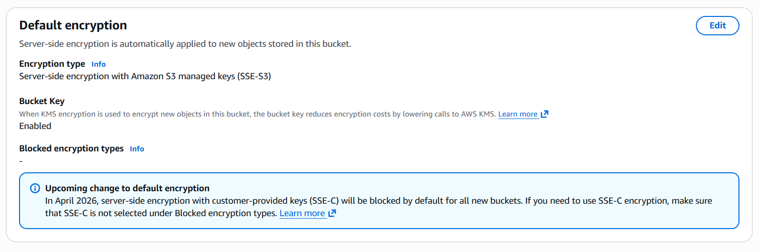
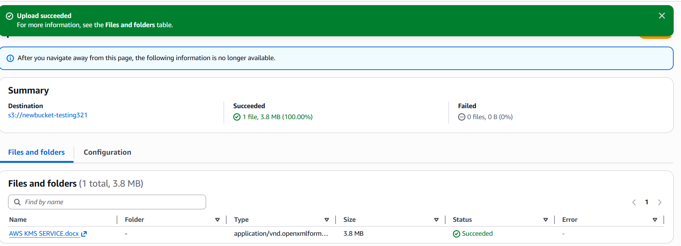
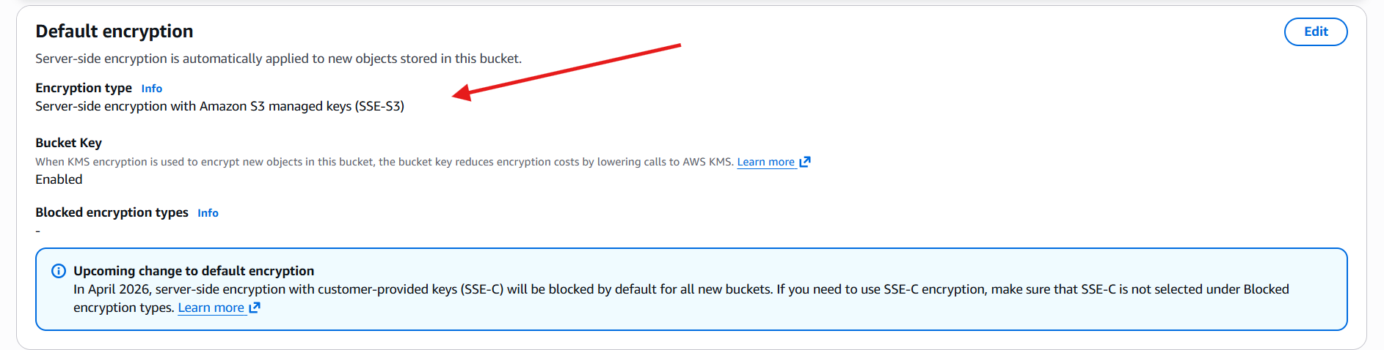
3. Create Encrypted EBS Volume
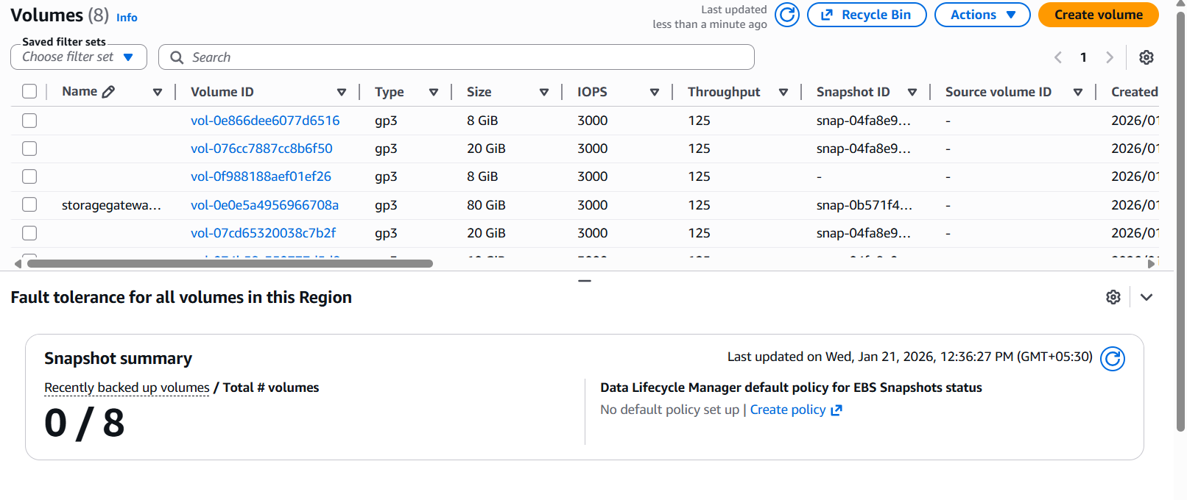
- 1.Go to EC2 → Volumes
- 2.Click Create volume
- 3.Enable Encryption
- 4.Select KMS key ebs-key
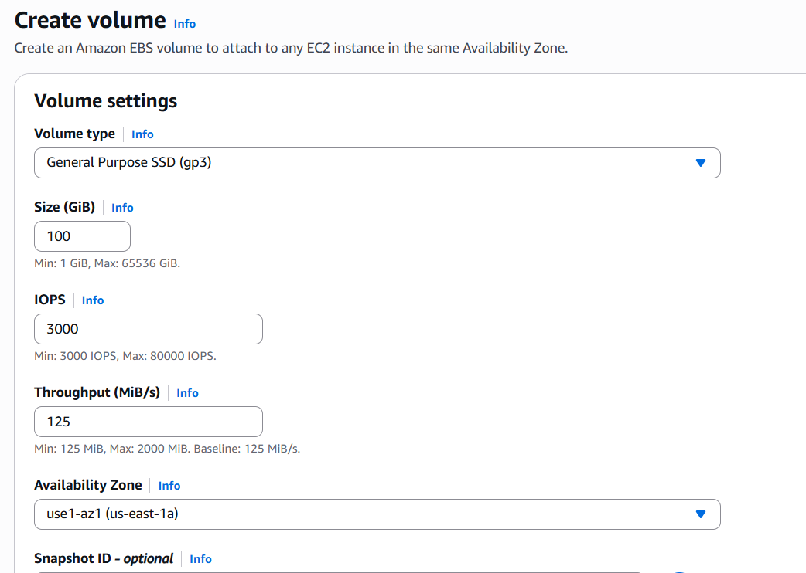
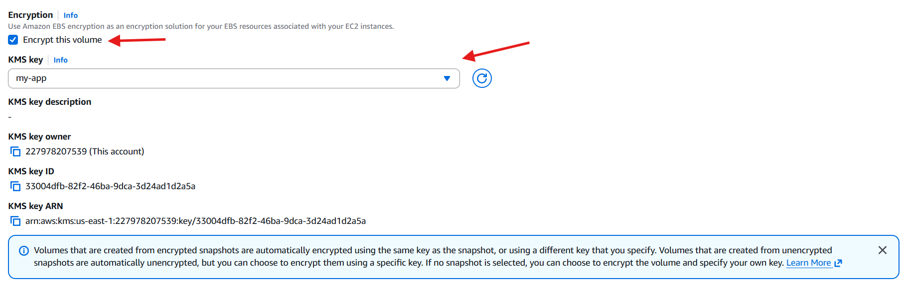
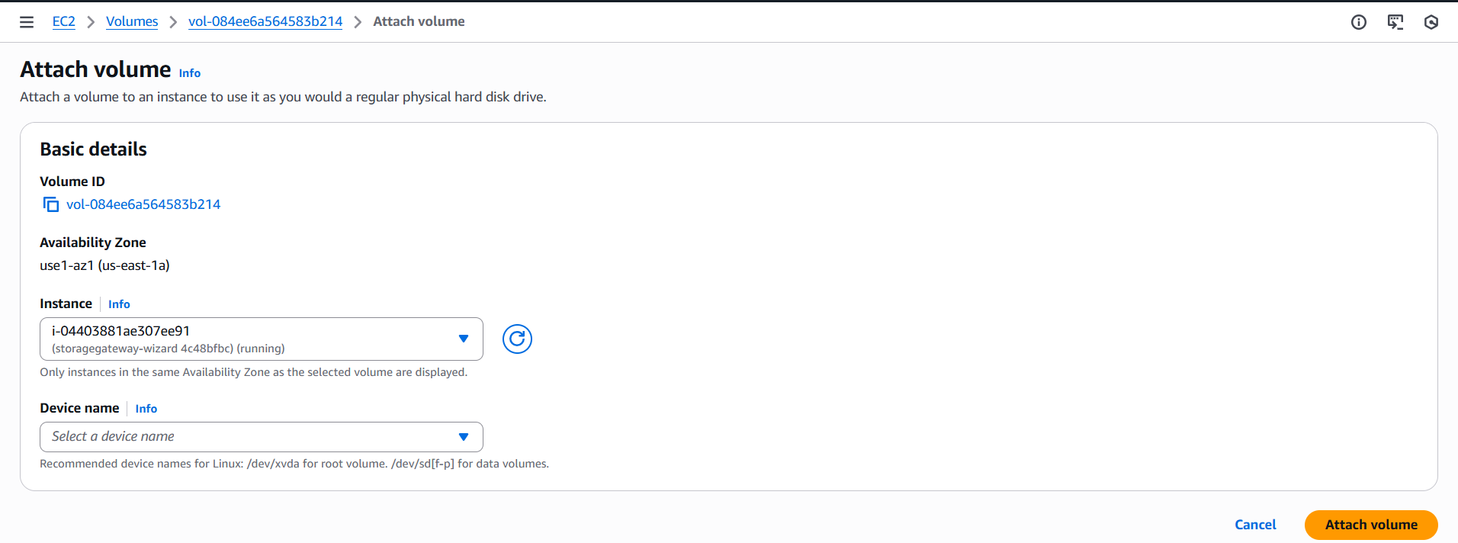
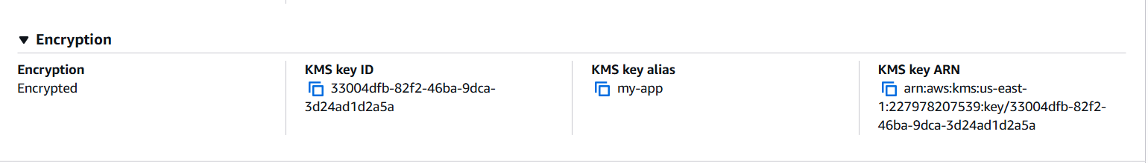
4.Encrypt Lambda Environment Variables Using KMS

Create kms key
Alias: lambda-key
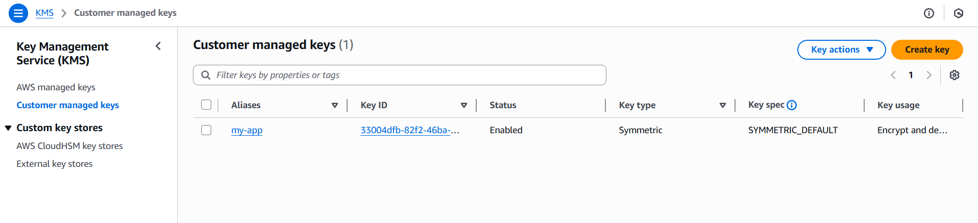
- Go to Lambda → Configuration
- Open Environment variables
- Add sensitive values (API keys)
- Choose Encryption key
- Select KMS key

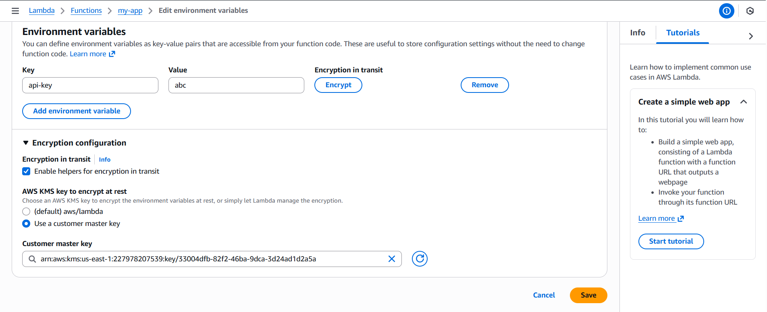
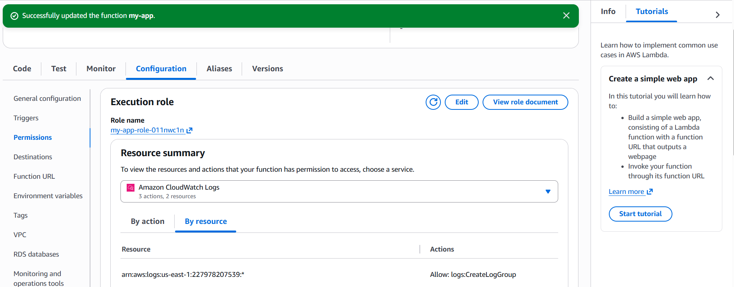
Test lambda
Ensure function executes successfully

